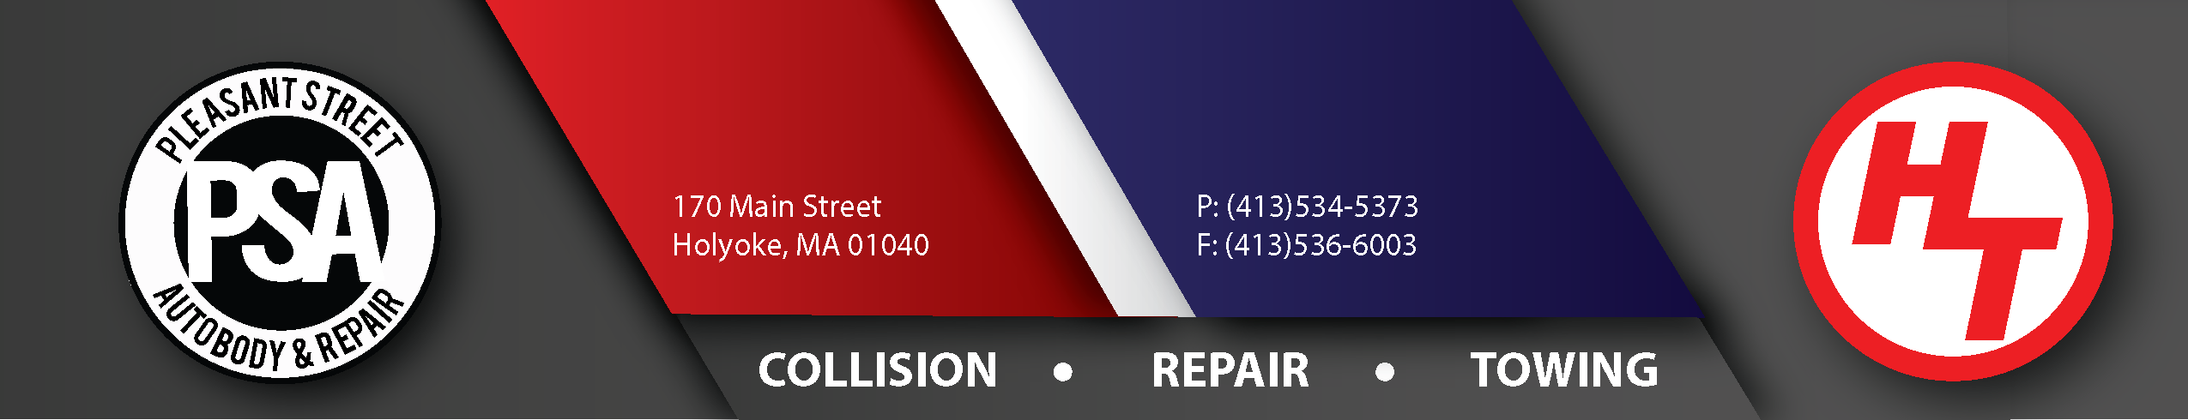

Hold Harmless & Indemnification Agreement

Date: _____/_____/_____

___________________________________________ hereby assumes all liability and holds harmless Pleasant Street Auto Body & Repair Inc., dba Hampshire Towing, its officers, agents, and employees.

We agree to indemnify and hold harmless all aforesaid parties from any claims, suits, or causes of action, including reasonable attorney’s fees for the defense therefore arising from not protecting the vehicle from inclement weather (covering broken windows, covering sunroofs, etc.) for vehicles that are in the car, custody, and control of Pleasant Street Auto Body & Repair Inc., dba Hampshire Towing.

Company: _________________________________________________________________________________

Signature: _________________________________________________________________________________

Print Name: ________________________________________________________________________________

Date: _____/_____/_____

--------------------------------------------------------------------------------------------------------------------------------------------------

Invoice/Towbook #: _____________________________________ Employee Name: _____________________

